COIT20273

Assessment item – 1

Project Proposal and Individual Learning Plan

Group Details:
Sr.No. | Student Name | Student ID
1 | Jay Niteshbhai Dobariya | 12278730
2 | Ketul Pareshbhai Patel | 12262547
3 | Aravind Reddy Dilli | 12253313
4 | Ajay Reddy Banda | 12282299

Table of Contents
1. Project Background and Justification 3
2. Problem Statement and Project Objectives 3
3. Innovative Aspects of Proposed Solution 4
4. Project Scope, Assumptions and Constraints 4
5. High-Level Requirements Overview 5
6. Work Decomposition 6
7. Delivery Roadmap 7
8. Risk Identification and Mitigation Plan 7
9. Quality Considerations 8
10. Team Structure, Roles and Responsibility Matrix 8
11. Task leads for Major Deliverables 9
12. Required Tools and Resources 10
References 10

Figure of Figures
Figure 1: Gantt Chart for WBS 6
Figure 2: Team Structure 8

Figure of Tables
Table 1: Project Scope (Inclusions and Exclusions) 3
Table 2: Functional and Non-functional Requirements 4
Table 3: Work break down structure 5
Table 4: Risk and Mitigation Plan 6
Table 5: Team Structure, Roles and Responsibility Matrix 7
Table 6: Task Leads 8

1. Project Background and Justification
In essence, there is no denying to the fact that the global ageing population is increasing at an accelerating pace due to which there is a rise observed in the cognitive health issues. These health issues can be identified as memory loss, reduced mental agility and dementia (Bang et al., 2023). Specifically for the elderly individuals, they often lack access to the continuous cognitive monitoring and other personalized mental health support, prime reasons for the effect on the cognitive health. Some of the traditional cognitive health solutions can be regarded as either manual, visiting hospitals frequently, generalization and other inefficient approaches (Lee et al., 2024).
In this concern, a new project is undertaken which primarily lays emphasis on proposing an AI-based cognitive health application which leverages artificial generative intelligence so as to perform the following functions:
- Providing with the personalized brain exercises
- Tracking out the cognitive performance over the time
- Supporting mental well-being
- Lastly, assisting the caregivers with the real-time insights

2. Problem Statement and Project Objectives
Problem Statement: A majority of elderly people face declining cognitive health but owing to the lack of accessible, personalized and continuous digital solutions, it makes them harder to improve their mental performance.
Project Objectives:
- To develop a mobile application that provides personalized AI-generated brain exercises to the elderly people for boosting their mental health performance.
- To design a system that works by tracking and analysing the cognitive performance over the period of time.
- To implement an AI-based mental health application that provides support to features such as mindfulness and emotional assistance.
- To enable all the caregivers as well as healthcare providers to monitor patient progress through the generated reports.
- To create a scalable and user-friendly solution suitable for the elderly users.

3. Innovative Aspects of Proposed Solution
The given below is the list of all the innovative aspects of the proposed mobile application solution:
- The integration of the generative AI will be done for the purpose of dynamic brain exercise generation (Denecke et al., 2021).
- There would be different personalized recommendations on the basis of the user performance and the behaviour.
- Another major aspect of the proposed solution is offering real-time cognitive analytics and insights to the users.
- This solution will also be supported with the AI-driven mental health support chat which can be accessed anytime anywhere.
- The solution will also come with automated caregiver reporting system.
- Another innovative aspect is to use the elderly friendly UI/UX interfaces which would be simple, and accessible.

4. Project Scope, Assumptions and Constraints
Project Scope
Table 1: Project Scope (Inclusions and Exclusions)
Inclusions | Exclusions
- Mobile application development  - AI-based exercise generation  - Performance tracking dashboard  - Mental health support module  - Caregiver reporting feature | - Integration with hospital databases  - Advanced medical diagnosis features  - Hardware device integration (wearables)

Assumptions
Some of the assumptions that have been made for the proposed mobile application project includes:
- Users will be having access to the smartphone in case the application needs to be used.
- All time internet connectivity is required for accomplishing various functions
- The users will be regularly interacting with the applications (Giebel et al., 2023)
Constraints
Though there are some constraints for this project like limited project timeline, limited data set for AI training, privacy and data security requirements and other technical limitations of the AI models (Denecke et al., 2021).

5. High-Level Requirements Overview
The table given below discusses all the functional and non-functional requirements of the mobile application.
Table 2: Functional and Non-functional Requirements
Functional Requirements | Non-functional Requirements
- The mobile application will be having the user registration and login features to allow logins and registration.  - The AI-generated brain exercises will be provided in the mobile application for supporting the elderly users.  - For all the users, the performance tracking dashboard will also be available.  - Even the mental health support will be provided on the basis of the chat or different exercises.  - For the caretakers, the report generation will be carried out.  - For all the users, the mobile application will be generating notifications and reminders. | - The major non-functional requirement is to ensure higher usability where elder friendly UI/UX aspects must be adhered.  - From the security and privacy point of view, it is mandatory to keep all the data protected from evolving cyber threats.  - The mobile application must show 99.9% reliability and up time.  - The overall response to the user’s query must be fast as it should not have any hanging related issues.  - The mobile application is required to be scalable enough in order to support future users (Or et al., 2022).

6. Work Decomposition
The table is given below that breaks down the major phases and their deliverables, thereby, creating a work break down structure.
Table 3: Work break down structure
Project Phases | Sub-Phases
Project Initiation | - Defining the Project scope  - Identifying all internal and external stakeholders  - Approving from the higher authorities
Requirement Analysis | - Gathering all the user requirements  - Listing functional requirements  - Listing non-functional requirements  - Creating use case diagrams
System Design | - UI/UX Designs  - Database Designs  - System Architecture design
Development | - Front-end deployment for the mobile application  - Backend development for the mobile application  - AI model integration
Testing | - Unit testing  - Integration testing  - User acceptance testing
Deployment | - App deployment  - Documentation
Maintenance | - Fixing out all the bugs  - Performance optimization

7. Delivery Roadmap
For showing the roadmap, the Gantt chart is created and attached below.
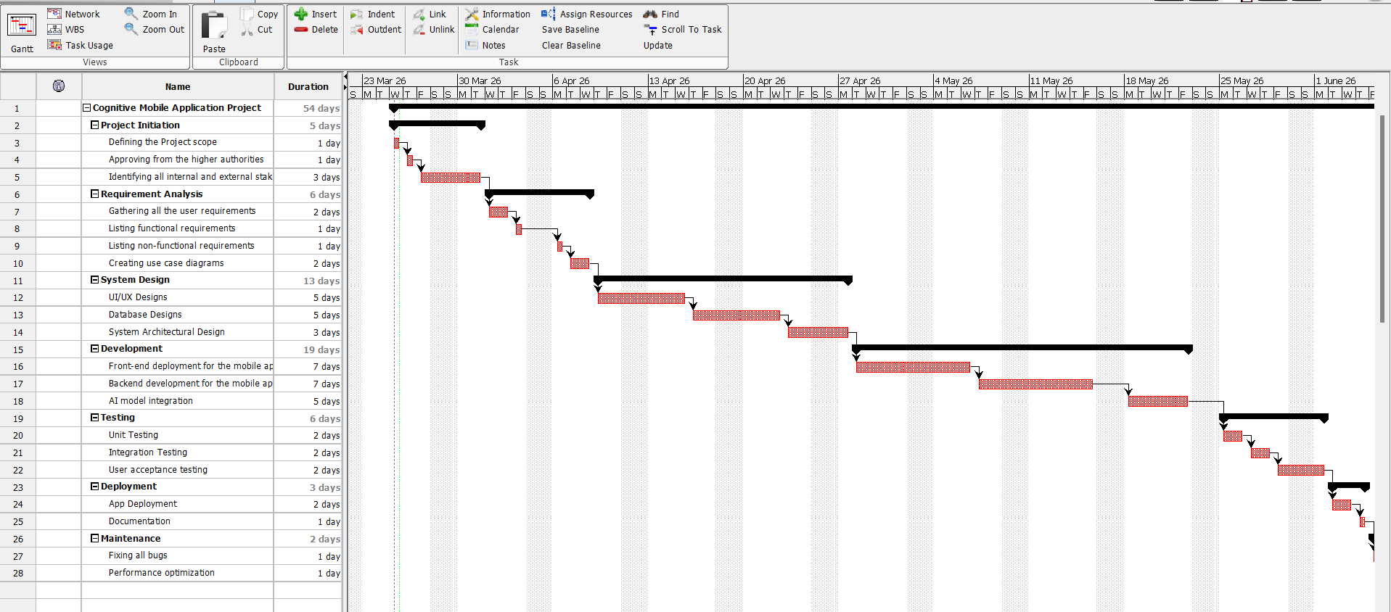
Figure 1: Gantt Chart for WBS

8. Risk Identification and Mitigation Plan
The table is given below that identifies all the risks, their impact and mitigation strategies that can be followed for it.
Table 4: Risk and Mitigation Plan
Potential Risks | Impact | Mitigation Strategy | Risk Level
Possibility of AI model inaccuracy | Incorrect recommendations | Use validated datasets and testing | Moderate
Data privacy related issues | Legal and ethical issues | Implement encryption and secure storage | Moderate
Poor user adoption rate | Low engagement | Design simple and intuitive UI | Moderate
Technical integration issues | Delays in development | Use proven frameworks and APIs | High
Time constraints | Incomplete project | Proper planning and task allocation | Low
Lack of real-world data | Reduced effectiveness | Use simulated datasets | Moderate

9. Quality Considerations
Even though there are some quality considerations which must be made for designing and developing the mobile application such as:
- Making sure higher usability for the elderly users
- Performing the continuous testing via unit and integration approaches
- Maintain the data accuracy rate and overall reliability
- Adhering to the secure coding practices
- Validating all the AI outputs prior to the implementation
- Making sure the system performance remains high and scalability is achieved

10. Team Structure, Roles and Responsibility Matrix
Some of the team members would be Project Manager, Business Analyst, Developer and AI/ML Engineer. The given below is the responsibility matrix for the same that lists all the responsibilities of the team members.
Table 5: Team Structure, Roles and Responsibility Matrix
Role | Responsibilities
Project Manager | Planning, coordination, and timeline management
Business Analyst | Requirement gathering, and documentation
Developer | App and backend development
AI Engineer | AI model design and integration
Diagram:
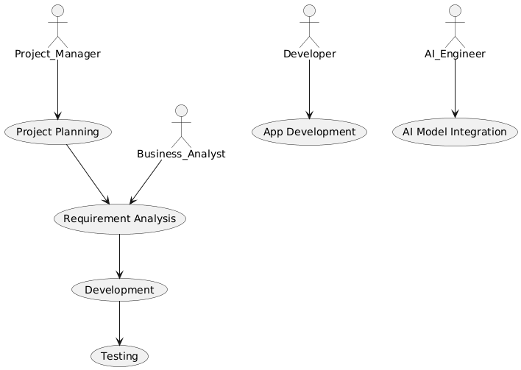
Figure 2: Team Structure

11. Task leads for Major Deliverables
Table 6: Task Leads
Task | Lead
Requirement Analysis | Business Analyst
UI/UX Design | Developer
AI Integration | AI Engineer
Testing | Developer
Documentation | Project Manager

12. Required Tools and Resources
- Programming: Flutter / React Native
- Backend: Node.js / Firebase
- AI Tools: Python, OpenAI API / ML models
- Database: Firebase / MongoDB
- Project Management: Project Libre, Trello or Project
- Design Tools: Balsamiq

References
- Bang, M., Jang, C. W., Kim, H. S., Park, J. H., & Cho, H. E. (2023). Mobile applications for cognitive training: Content analysis and quality review. Internet Interventions, 33, 100632. https://doi.org/10.1016/j.invent.2023.100632

- Denecke, K., Schmid, N., & Nüssli, S. (2021). Implementation of Cognitive Behavioral Therapy in e–Mental Health Apps: Literature review. Journal of Medical Internet Research, 24(3), e27791. https://doi.org/10.2196/27791

- Giebel, G. D., Speckemeier, C., Abels, C., Plescher, F., Börchers, K., Wasem, J., Blase, N., & Neusser, S. (2023). Problems and Barriers related to the use of Digital Health Applications: Scoping review. Journal of Medical Internet Research, 25, e43808. https://doi.org/10.2196/43808

- Lee, M., Park, J., & Lee, S. (2024). Effects of Mobile Health Applications in Older Adults with Dementia or Mild Cognitive Impairment: A Systematic Review and Meta-Analysis. Korean Journal of Adult Nursing, 36(2), 112. https://doi.org/10.7475/kjan.2024.36.2.112

- Or, C. K., Holden, R. J., & Valdez, R. S. (2022). Human Factors Engineering and User-Centered Design for Mobile Health Technology: Enhancing Effectiveness, efficiency, and satisfaction. In Automation, collaboration, and e-services (pp. 97–118). https://doi.org/10.1007/978-3-031-10788-7_6

